PROJECT DESCRIPTION:
Shopping Spree Excel Project
You have won a contest for a $2500 shopping spree at a store of your choice. You must buy five items from your favorite store’s website and the total cost, with tax, must be between $2450 and $2500 or you lose it all. You must purchase FIVE and only FIVE different items. You can purchase multiple quantities of an item (purchase multiples of at least TWO items)
WORKSHEET SET-UP:
- Create a new Microsoft Excel workbook and save as LastName FirstInitial ShoppingSpree.
- Rename the Sheet Tab “Spree” and give it a color.
- Select Columns A and G (Use the Ctrl key) & change the width of these columns to 2.57.
- Select cells A1:G1, A2:A18, G2:G18, B3:F3, B5:F5, B16:F18
  - Change the shading of these cells (or fill color).
- Select cells A1:G18. Put a thick border on the outside of these cells.
- Adjust column B width to 1.86.
- Adjust columns D, E and F width to 13.14.
- In cell B7 enter a 1. In cell B8, enter a 2. In cell B9, enter a 3. In cell B10, enter a 4. In cell B11, enter a 5.
- In cell C6, type Item/Description. Bold, Underline, and Center this cell. Adjust column width if needed.
- In cell D6, type Quantity. Bold, Underline, and Center this cell.
- Select cells D7:D11 and Center align.
- In cell E6, type Price. Bold, Underline, and Center this cell.
- In cell F6, type Cost. Bold, Underline, and Center this cell.
- In cell E12, type SUBTOTAL. Bold and Right Align this cell.
- In cell E13, type TAX. Bold and Right Align this cell.
- In Cell E14, type TOTAL. Bold and Right Align this cell.
- In Cell E15, type Cash Left. Bold and Right Align this cell.
- Select cells E7:F11 and F12:F15. Format the numbers as Currency.
- Select cells B6:F12. Put a border on the outside and inside of these cells. Change the color of the lines.
- Select cells B13:F15. Put a border on the outside of these cells. Change the color of the lines.
WORKSHEET TITLE:
- In Cell B2, type [Your Name] Shopping Spree. Change the color of the font to a color of your choice.
- Select cells B2:F2. Merge and Center these cells. Change the font to one of your choice and change the size to around 26ish. Adjust column width if needed to view complete text.
- Put a border on the outside of these cells (B2:F2). Change the color of the lines.
- Select cells B4:F4. Merge and Center these cells. Change the font to one of your choice and change the size to around 14ish. Change the font color to a color of your choice.
- Put a border on the outside of these cells (B4:F4). Change the color of the lines.
FORMULAS
- In cell F7, enter a formula to multiply the Quantity by the Price. Use the Fill Handle to copy formula down to F11.
- In cell F12, use the SUM function to add cells F7:F11.
- In cell F13, type a formula that will calculate sales tax on the purchase. The sales tax rate in Montgomery County is 7.5%. Hint: Subtotal * Tax Rate
- In cell F14, type a formula that will add the Subtotal and the Tax amounts.
- In cell F15, type a formula that will tell you how much cash you have left over from the $2500. You will need to subtract your Total amount from 2500.
- In cell F17, Center Align the cell and type the following function/formula:
  - =IF(F14<2500, “Jackpot!”, “Try Again”)
- Select cell F17. Put a border on the outside of the cell and change the fill color to No Fill. Change the color of the lines.
- Save your spreadsheet.
SHOPPING
- Visit a store’s website to select your FIVE items. Record the Item, Quantity, and Price on your spreadsheet.
- Enter your items and their information in cells C7 to E11.
- In cell B4, insert the address of your website.
COST BREAKDOWN CHART
- Select C7:C11 and F7:F11.
- Insert a pie chart (2D or 3D) or a column chart (2D or 3D).
- Give the chart the title, Cost Breakdown.
- Display the amounts in each pie slice or column (Select Chart>Chart Tools>Design>Chart Layouts>Add Chart Element>Data Labels).
- Change the color of each pie slice or column.
- Apply an outside border to the chart. Format the color and weight of the line.
- Position the chart under your table.
FINISHING TOUCHES
- Adjust font style, font size and column width as necessary to see all information.
- Check cell B2 so that you can see all of the title. Adjust formatting as needed.
- Check to make sure that your Total price is correct.
- Also make sure that you have a Jackpot! in cell F17. If that is displayed, you stayed under your $2500 budget.
- Save your spreadsheet and submit.
Mr. Kurtz’s Example
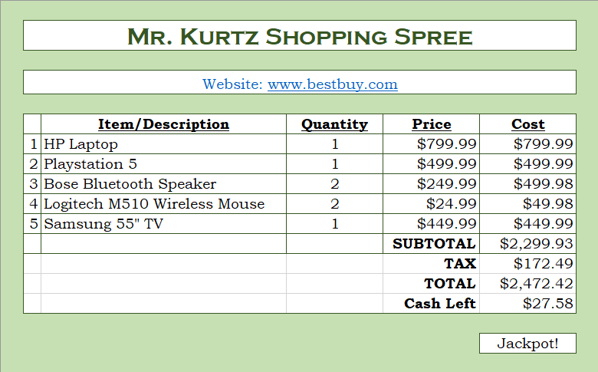

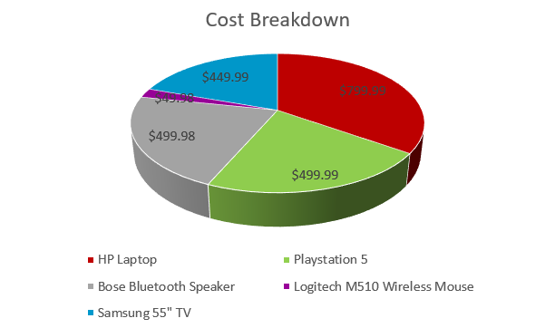
Shopping Spree Rubric
Name_________________________ Period______

Element |  | Points Possible | Score
Setup | Filename | 2
 | Sheet Name & Color | 2
 | Columns A & G 2.57 wide | 2
 | Shading | 2
 | Outside Border | 2
 | Proper Spelling & Capitalization | 2
 | Columns Adjusted to Display Text | 2
Title | Merge & Center | 2
 | Size & Style | 2
 | Borders (Title & Website) | 2
 | Website Address | 2
Items | Headings Bold, Underline, Center | 3
 | Borders (Inside & Outside) | 2
 | Price formatted as Currency | 2
 | Subtotal, Tax, Total, Cash Left Bold & Right Align | 2
 | Five Items and information | 5
Formulas | Subtotal SUM function | 3
 | Tax Calculation | 3
 | Total Calculation | 3
 | Cash Left Calculation | 3
 | IF function correct | 2
Pie Chart | Insert a Pie Chart | 2
 | Chart Title | 2
 | Display Labels | 2
 | Pie Slice Colors | 2
 | Outside Border | 2
TOTAL |  | 60

