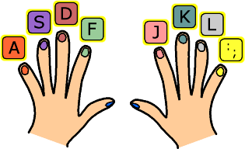**Keyboarding Technique**

1. Sit with correct posture
2. Keep your fingers curved on the home row keys
3. Elbows in tight to your side
4. Feet positioned for balance, flat on the floor
5. Center your body to the “H” key
6. Never rest wrists on the keyboard
7. Keep eyes on printed copy

**Home Row Keys**

“A”- Left Pinkie “S”- Left Ring “D”- Left Middle “F”- Left Pointer

“J” – Right Pointer “K”- Right Middle “L”- Right Ring “;”- Right Pinkie

