Inserting Objects
Insert>Illustrations, Insert>Text
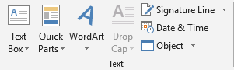
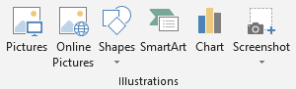

Directions:
- Save this document as LastName FirstInitial Working with Objects to your flash drive (in your Word folder).
- Insert a Picture from file.
  - Download the Viking head.
  - Change the text wrapping to Behind Text
  - Resize and rotate the image.
- Insert an online picture of a plane.
  - Change the text wrapping to In Front of Text.
  - Select the image to display the Picture Tools Format tab.
  - Resize and rotate the image.
- Insert a shape of your choice.
  - Select the shape to display the Drawing Tools Format tab.
  - Resize and rotate the shape.
- Insert a WordArt.
  - Type [This is WordArt].
  - Select the WordArt to display the Drawing Tools Format tab.
- Insert a Simple Text Box.
  - Type [This is a Text Box].
  - Select the text box to display the Drawing Tools Format tab.
- Arrange the objects in this order: Plane in front of the Shape (resize), WordArt in front of Viking Head, Text Box in front of shape, behind plane

Formatting Pictures
Picture Tools Format
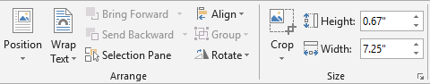
Directions:
- Select the image of the Viking Head
  - Remove the background
  - Go through the Corrections
  - Go through Color
  - Go through Artistic Effects
- Select the image of your plane
  - Format the picture border
    - Color, Weight, Style
  - Format a picture effect
- Select the image of the Viking Head
  - Apply a Picture Style

Formatting Shapes, WordArt, Text Boxes
Drawing Tools Format

- Select your shape
  - Change the Shape Fill
  - Change the Shape Outline
  - Change the Shape Effects
  - Apply a Shape Style
- Select your WordArt
  - Change the Text Fill
  - Change the Text Outline
  - Change the Text Effects
  - Change the Text Direction
- Select your text box
  - Place the text box over an image
  - Change the Shape Fill to No Color
  - Change the Shape Outline to No Outline

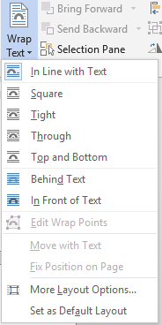
Inserting Objects: Insert Tab

# | Command | Description
1 | Pictures
2 | Online Pictures
3 | Shapes
4 | Text Box
5 | WordArt

Formatting Pictures: Picture Tools Format

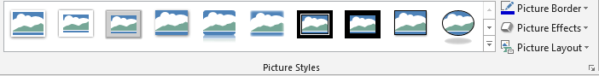
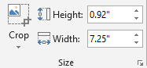
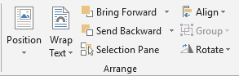
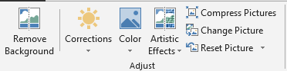

# | Command | Description
1 | Remove Background
2 | Corrections
 | Color
 | Artistic Effects
 | Position
 | Wrap Text
 | Bring Forward
 | Send Backward
 | Align
 | Group
 | Rotate
 | Crop
 | Picture Styles
 | Picture Border
 | Picture Effects

Picture Tools>Format

Drawing Tools>Format
