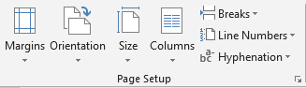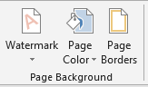

Directions:
- Save this document as LastName FirstInitial Page Layout & Design to your flash drive (in your Word folder).
- Change the Page Margins to Normal.
- Set Custom Margins: Top – 2”, Bottom - .5, Left - .75, Right - .75
- Change the Orientation to Landscape. Change the Orientation to Portrait.
- Open a new Word document
  - Make sure your ruler is visible (View>Show>Ruler)
- Format the layout to 3 columns
  - Type Column 1
  - Insert a Column break
  - Type Column 2
  - Insert a Column break
  - Type Column 3
  - Insert a Column Break
- Return to your Page Layout & Design document.
- Apply a Confidential Watermark.
- Remove the watermark.
- Apply a Custom Watermark with your name. Change the font style
- Change the page color.
- Remove the page color.
- Apply a Page Border.
  - Setting: Box
  - Line Style
  - Color
  - Change to an Art
- Save

Page Layout>Page Setup

# | Command | Description
1 | Margins
2 | Orientation
3 | Size
4 | Columns
5 | Breaks
6 | Line Numbers
7 | Hyphenation

Design>Page Background

# | Command | Description
1 | Watermark
2 | Page Color
3 | Page Borders

