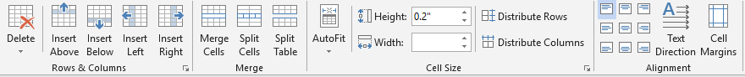
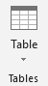

Insert Tab Table Tools>Layout
Directions:
- Save this document as LastName FirstInitial Formatting Paragraphs to your flash drive (in your Word folder).

Insert a Table: (Insert>Tables>Table)
- Insert a 4x3 Table
  - Drag Method
  - Type Method
- Number the cells 1-12

Format the Layout of a Table (Select or click in the table>Table Tools>Layout)
- Insert a row above Row 1 and below Row 2 (Rows & Columns)
- Insert a column to the right of Column 1 and to the left of column 3 (Rows & Columns)
- Delete Row 3 and Column 2 (Rows & Columns)
- Delete the table (Rows & Columns)
- Undo the table delete
- Merge Row 1 cells (Merge). Type [Miamisburg Middle School]
- Adjust Row Height in Row 1 to .5” (Cell Size)
- Change the text alignment in Row 1 (Alignment). Cycle through the alignments and choose Align Center.

Table Tools>Design
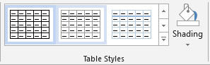
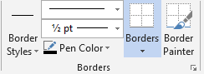

Format the Layout of a Table (Select or click in the table>Table Tools>Layout)

Number | Last Name | First Name | Salary
17 | Aggozino | Jeremy | $1,775,000
99 | Kimmet | Doug | $2,225,000
29 | Presar | Jeremy | $1,510,000
4 | Welsch | Troy | $780,000
34 | Osterloh | Jason | $1,035,000

- Add a new row 1 and key [Ohio Northern Football] (Rows & Columns)
- Change the width of column 1 to .75” (Cell Size)
- Merge column 1 cells, Align Bottom Center (Merge, Alignment)
- Change the height of row 1 to .5” (Cell Size)
- Manually adjust width of column 4 to the right margin
- Distribute columns 2-4 (Cell Size)
- Sort the table by Last Name (Data)
- Sort the table by Number (Data)
- Change text direction in row 1, then undo (Cell Alignment)
- Shade row 1 (Design>Table Styles)

Table Borders & Styles (Select or click in the table>Table Tools>Design)
- Insert a 3x4 table
- Select the entire table. Apply a dashed line outside border (Borders)
- Change the line style to solid, weight to 1 ½ pt, and pen color of the lines. Apply to the Inside Borders (Borders)
- Select the two middle cells and remove the top and bottom borders (Borders)
- Select the entire table and apply a Table Style. Notice each style has a specific name displayed with the screentips. (Table Styles)

Insert Tab>Tables Group

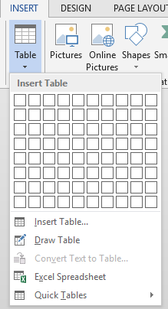  1.  2.  3.  4.  5. | 1. Insert Table:  2. Insert Table:  3. Draw Table:  4. Excel Spreadsheet:  5. Quick Tables:

Table Tools>Layout

# | Command | Description
1 | Delete
2 | Insert Above
3 | Insert Below
4 | Insert Left
5 | Insert Right
6 | Merge Cells
7 | Split Cells
8 | Split Table
9 | AutoFit
10 | Height
11 | Width
12 | Distribute Rows
13 | Distribute Columns
14 | Align Top Left
15 | Align Top Center
16 | Align Top Right
17 | Align Center Left
18 | Align Center
19 | Align Center Right
20 | Align Bottom Left
21 | Align Bottom Center
22 | Align Bottom Right
23 | Text Direction
24 | Cell Margins

Sorting

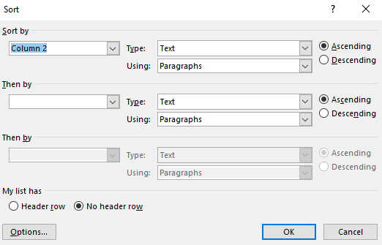
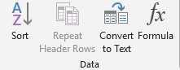

Steps when sorting:
- Select the table/data you would like to sort
- Choose your Sort by criteria
  - You may check the My list has Header row to display the column name in the Sort by box
- The Type: should match your data (Text for text, Number for numbers)
- Select Ascending or Descending
- Click OK
*NOTE: The Then by sections are the next levels you could sort by. Example: Sort by last name, then by grade.

