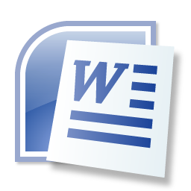
Microsoft Word Notes

Microsoft Word is a _____________________________ used to create ____________________, ____________________, ____________________ and more.

A Word file is called a _______________.

The file extension for Word is __________.

The Word Start Screen

From here, you can:
1.
2.
3.

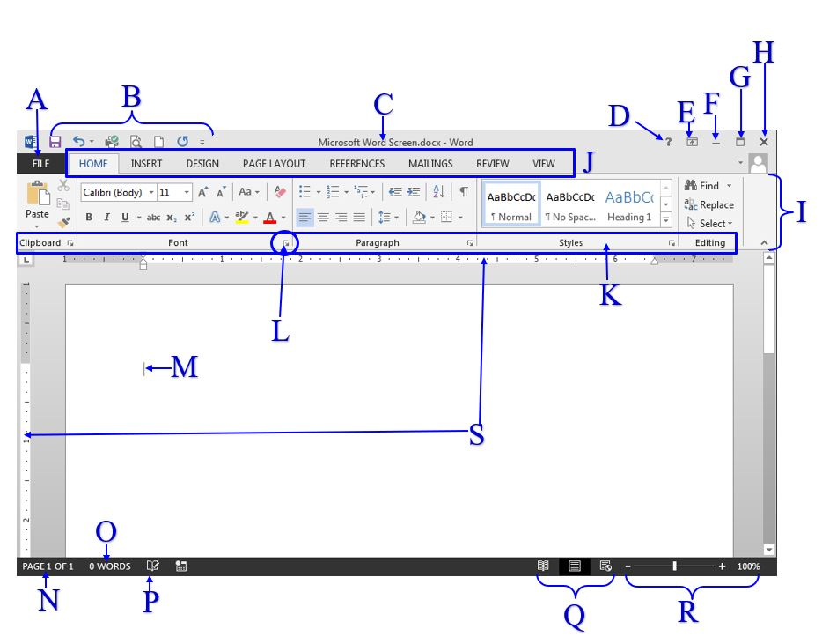
Microsoft Word Screen
 | Name | Description
A | File Tab
B | QAT
C | Title Bar
D | Word Help
E | Ribbon Display
F | Minimize
G | Restore Down
H | Close
I | Ribbon
J | Tabs
K | Groups
L | Dialog Box
M | Insertion Point
N | Page Indicator
O | Word Count
P | Proofing
Q | Views
R | Zoom
S | Ruler

Reading Instructions/Directions to Complete a Word Task
Click here to access GCFLearnFree website for interactive exploration of the Word screen.

INSTRUCTION: Change the right page margin to .5” (Page Layout>Page Setup>Margins>Custom Margins>Right Margin)

Dissecting the Instruction

(Page Layout>Page Setup>Margins>Custom Margins>Right Margin)
Options & Sections
Command
Group
Tab

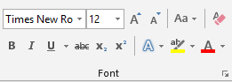
Dialog Box
*Bottom right corner of a group
*Provides more formatting options for a group
*Not all groups have dialog boxes

NOTES:

