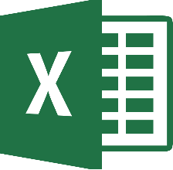
A
Microsoft Excel
B

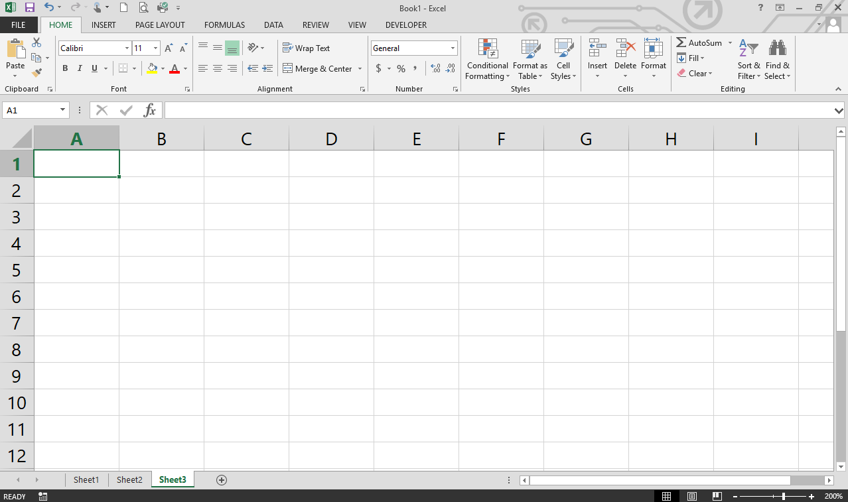
N
D
J
M
L
K
I
H
G
F
E
C
*Click this link to access the GCF site to view an interactive Excel Screen.
 | Name | Description
A
B
C
D
E
F
G
H
I
J
K
L
M
N

*Ribbon Parts
- Tabs
- Groups
- Commands
- Dialog Boxes

