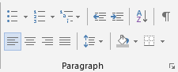
Directions:
- Save this document as LastName FirstInitial Formatting Paragraphs to your flash drive (in your Word folder).
- In the Bullets section below, bullet point 3 characteristics you value in a person.
- In the Numbering section below, number your 3 favorite colors.

Decrease the indent of this line 2 times.
Increase the indent of this line 3 times.

- Apply the correct alignment to the words below:
Left
Center
Right
- Apply Green shading to this line
- Apply an outside border to this line of text
- Line spacing is the amount of space that appears between the lines of typed text. When we reach the right side of the page, the text continues to the next line. Select the text in #7 and watch the spacing changes as you cycle through. Set the line spacing to #7 to 1.5
- Make the following changes to the Aloha from Hawaii section:
  - Remove the space after the title (Paragraph spacing)
  - Remove the shading
  - Add a top border
  - Change the title font size to 24 pt

- Save the file.

Bullets | Numbering

Aloha from Hawaii
There are six major islands to visit in Hawaii: Kauai, Oahu, Molokai, Lanai, Maui, and the island of Hawaii! Each has its own distinct personality, adventures, activities and sights. We invite you to explore the Islands of Aloha to find your own heavenly Hawaii experiences.

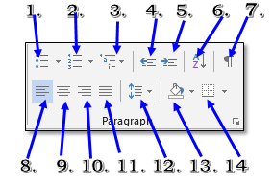
Home Tab>Paragraph Group

# | Command | Description
1 | Bullets
2 | Numbering
3 | Multilevel List
4 | Decrease Indent
5 | Increase Indent
6 | Sort
7 | Show/Hide
8 | Align Left
9 | Center
10 | Align Right
11 | Justify
12 | Line and Paragraph Spacing
13 | Shading
14 | Borders
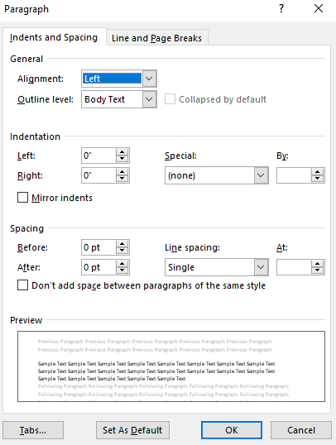

Font Dialog Box
