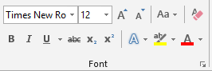
Directions:
- Save this document as LastName FirstInitial Formatting Text to your flash drive (in your Word folder).
- Change the font of all of this line to Georgia 14 pt.
- Using the Increase Font Size command, change the font size of this line to 20 pt.
- Using the Decrease Font Size command, change the font size of this line to 7 pt.
- Change Case to Uppercase.
- Change Case to capitalize each word.
- Bold the word bold in this sentence.
- Italic the word italic in this sentence.
- Underline the word underline this sentence.
- Strikethrough this line.
- Subscript the 2 in H20.
- Superscript the 2s in the equation: a2 + b2 = c2

Text Effects: Apply the Text Effect to the entire line
- Outline: Blue Accent 1
- Shadow: Outer Shadow of your choice
- Reflection: Full Reflection, 8 pt offset
- Glow: Choose a glow from the 2nd row
- Outline, Shadow, Reflection, Glow
- Highlight this line with the Text Highlighter
- Change the font color of this line to Dark Blue, Text 2
- Format Painter: Use the Format Painter to apply formatting of #17 to this line.
Font Dialog Box

- Apply Small Caps to this line
- Apply All Caps to this line
- Complete the sentence below and apply the formatting changes: Change the font style, size 18 pt. and change the font color. Apply bold and underline to “favorite”, apply a text effect to the activity. Apply small caps to the activity.

My favorite thing to do is

- Save the file.

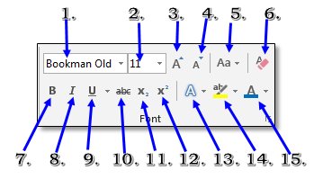
Home Tab>Font Group

# | Command | Description
1 | Font
2 | Font Size
3 | Increase Font Size
4 | Decrease Font Size
5 | Change Case
6 | Clear Formatting
7 | Bold
8 | Italic
9 | Underline
10 | Strikethrough
11 | Subscript
12 | Superscript
13 | Text Effects:
14 | Text Highlighter
15 | Font Color
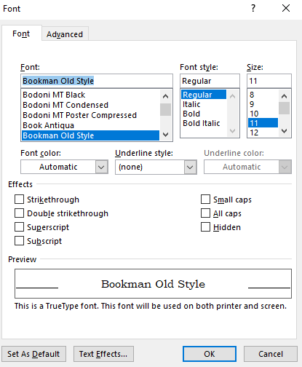

Font Dialog Box

